Project Design Phase
Solution Architecture
Date 30 June 2025
Team ID LTVIP2025TMID49757
Project Name Visualization Tool for Electric Vehicle Charge and Range Analysis
Maximum Marks 4 Marks
Solution Architecture:
Solution architecture is a complex process – with many sub-processes – that bridges the gap between business problems and technology solutions. Its goals are to:
- Find the best tech solution to solve existing business problems.
- Describe the structure, characteristics, behavior, and other aspects of the software to project stakeholders.
- Define features, development phases, and solution requirements.
- Provide specifications according to which the solution is defined, managed,and delivered.
Example - Solution Architecture Diagram:
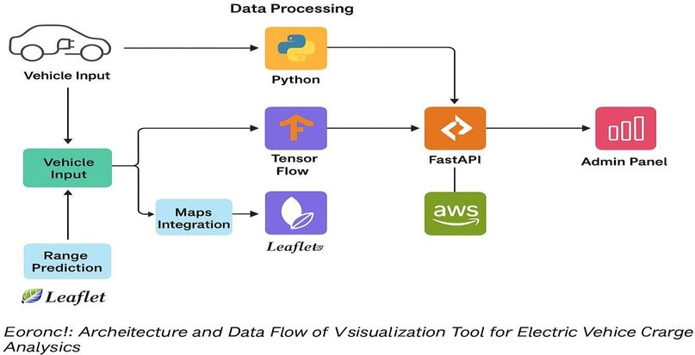
Figure 1: Architecture and data flow of the voice patient diary sample application
Reference: https://aws.amazon.com/blogs/industries/voice-applications-in-clinical-researchpowered-by-ai-on-aws-part-1-architecture-and-design-considerations/

